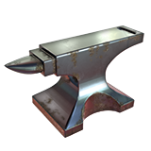

ACME Manufacturing
5678 Wylie Coyote Avenue
Abbotsford, B.C.
D4E 5F6

Road Runner Enterprises
1234 – Park Drive
Vancouver, BC
A1B 2C3

